**Christa Noel Robbins**

**Rosenberg, Harold (1906-1978) Word Count: 534**

Harold Rosenberg was a poet, political theorist, and cultural critic. Today Rosenberg is best known as one of the most influential advocates of New York School painting, to which he gave the name “Action Painting.” Born and raised in Brooklyn, New York, within an immigrant, Jewish community, Rosenberg first earned a law degree before embracing the bohemian lifestyle of the artists and activists of Lower Manhattan. Rosenberg began his career as a writer focused on literary criticism and political theory, with his first essays appearing in *Partisan Review* and *New Masses*. He became interested in visual art after developing a close relationship with downtown painters, such as Arshile Gorky and Willem de Kooning, and further cultivated that interest while working on the Mural Division of the WPA’s Federal Arts Project. While Rosenberg began writing about visual art in the early forties with essays such as ‘On the Fall of Paris’ (1940)—which asserted that New York City had displaced Paris as the cultural capital of the world—it is his 1952 essay, ‘The American Action Painters,’ for which he is best known. In that essay Rosenberg notoriously defined New York School painters in terms of the actions they performed, as opposed to the pictures they produced.

‘The American Action Painters’ was first proposed by Rosenberg for publication in *Les Temps Moderne* (then edited by Simone de Beauvoir, Maurice Merleau-Ponty and Jean-Paul Sartre). Rosenberg, who had previously published an essay on Communism n the journal, pitched “The American Action Painters,” as a chance to inform French audiences as to what direction art had recently taken in the U.S. Following a fall-out with Sartre, however, Rosenberg pulled the essay, which he then took to Thomas Hess at *Art News*. Rosenberg’s concept of ‘Action Painting’ was and continues to be received negatively by art critics and art historians. As Mary McCarthy put it around the time of its initial publication ‘You cannot hang an event on the wall, only a picture.’ Recent scholarship, however, has contributed to a more nuanced reading of the text in relation to Rosenberg’s long-term commitment to Marxist theory and his particular interest in notions of agency and identity. These are themes Rosenberg pursued in numerous books and essays since writing his most important essay “Character Change and the Drama” in 1932, where he pursued the terms of character-development in relation to the external structures of both dramatic and legal form. The question of agency and identity is addressed with great sensitivity in Rosenberg’s 1962 book *Arshile Gorky: The Man, The Time, The Idea*, as well as in a 1967 collection of essays on the subject titled *Act and the Actor: Making the self*. Rosenberg died in 1978 in New York, City.

**References and Further Reading:**

O’Brien, E. (1997) *The Art Criticism of Harold Rosenberg: Theaters of Love and Combat*. Ph.D. The City University of New York.

Orton, F. (1991) “Action, Revolution and Painting.” *Oxford Art Journal* 14.2, pp. 3-17

Robbins, C. N. (2012) “Harold Rosenberg on the Character of Action.” *Oxford Art Journal* 35.2, pp 195-214.

Rosenberg, H. (1964) *The Anxious Art Object: Art Today and its Audience.* New York, NY: Horizon Press.

——. (1965) *The Tradition of the New*. New York, NY: McGraw-Hill Book Company.

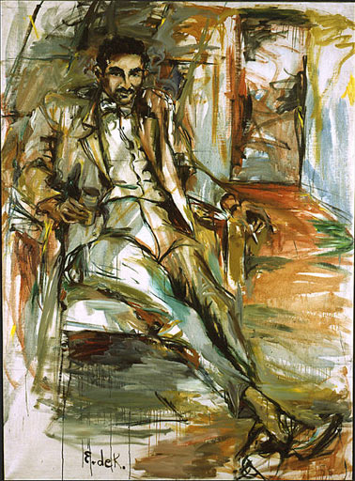

Elaine de Kooning, *Harold Rosenberg*. Oil on canvas, 1956  
National Portrait Gallery, Smithsonian Institution, Washington, D.C.

<http://www.npg.si.edu/exh/brush/rosen.htm>